**ERSTEN**: WEBSITE REVAMP

1. CAN YOU REMOVE **WE ARE WEB DESIGN ETC**..EVEN IN DEMO PLEASE DO NOT KEEP THESE.

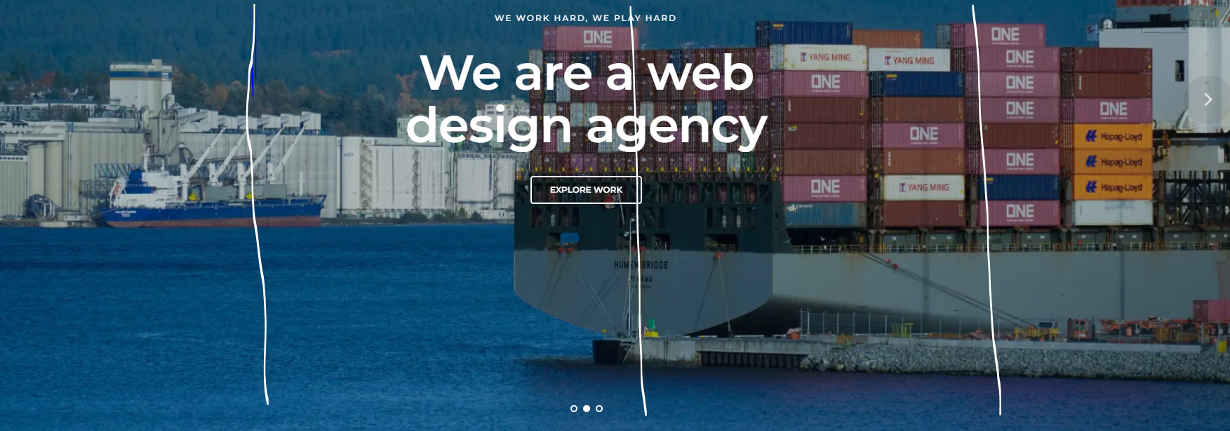

1. 4 IMAGES ON EACH VERTICAL CAN BE SCROLLED IN THE INTRO PAGE
2. SUPPLY CHAIN MANAGEMENT PARTNER FOREVER – **TAGLINE** ON THE BANNER WITHOUT INTERFERING THE IMAGES

TAGLINE - DRIVING INNOVATION ACROSS ENERGY, HOSPITALITY, AND FOOD WASTE MANAGEMENT

1. WHEN THE PAGES ARE SCROLLED DOWN THE HEADER ALSO SHOULD FOLLOW DOWN
2. KEEP A MARK WHICH INDICATES THAT THIS WEBSITE IS BAHRAIN ..ON THE RIGHT / LEFT SIDE OF THE WEBPAGE
3. **FOOTER –** REMOVE THE EXISITING ..INSTEAD PLACE AS PER BELOW , BUT MATCHING TONE AS PER THE TOTALITY OF THE WEBSITE



1. COLOR COMBINATIONS OF THE IMAGES SHOULD HAVE CONSISTENCY. HEADINGS / SUB HEADINGS SHOULD MATCH WITH OUR CORPORATE LOGO
2. **COLLABARATION** – **RELAIBILITY** – **SUPPORT** – **CREATIVITY** ..INSTEAD OF THE BELOW

COLLABARATION: UNIFIED EFFORTS, UNMATCHED RESULTS. TOGETHER, WE CRAFT SOLUTIONS THAT EXCEED EXPECTATIONS

RELIABILITY: CONSISTENCY YOU CAN COUNT ON. BUILDING TRUST THROUGH DEPENDABLE SERVICE.

SUPPORT: EMPOWERING SUCCESS THROUGH UNWAVERING ASSISTANCE. TOGETHER, WE NAVIGATE CHALLENGES AND ACHIEVE GOALS

CREATIVITY**:** REIMAGINING POSSIBILITIES. INNOVATING WITH PURPOSE TO SOLVE CHALLENGES

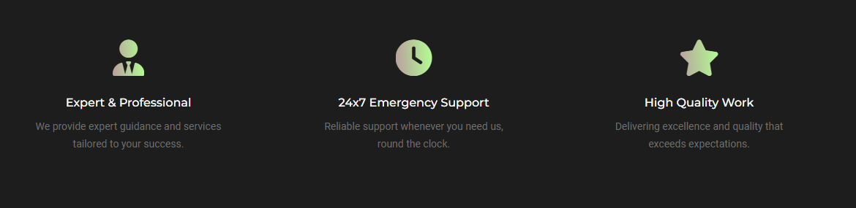

**BANNER IMAGES – FRONT SCROLL IMAGES**





















